CAS PY 106

In-Class Note 16

1. Relation between E-fields and B-fields?
2. Charges generate E fields

E = kq/r^2

1. Charges in an E-field feel a force:

F = qE

1. Moving charges (currents) in a B-field feel a force:

F = ILB\*sin(theta)

1. Magnetic field around a long straight wire
2. 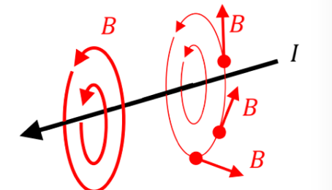
3. Magnetic field lines indicate direction of magnetic field at different points
4. Magnetic field around a long straight wire
5. Magnitude B-field around long straight wire

B = u\*I/2pi(r)

I = current in Amps

r = distance between wire and where you measure your B-field

u = permeability constant = 4pi\*10^-7

1. 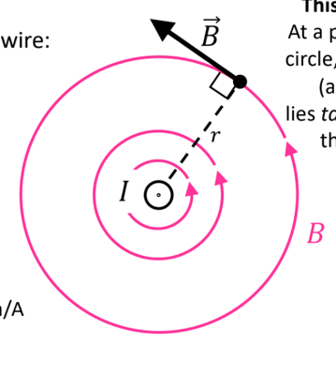
2. Forces between two wires
3. Two wires next to each other apply a force on each other
4. 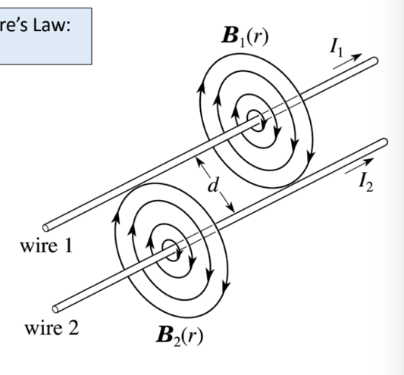
5. To calculate the force: choose either wire as the “source” and the other wire as the one that feels the force
6. 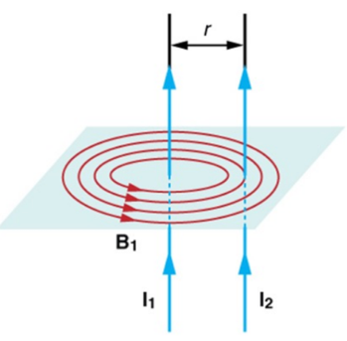
7. What is the force on the right wire I2 due to left wire w1?

F2 = I2\*L\*B1 = I2\*L\*u\*I1/2pi(r)

1. If the currents go through wires in the same direction, the wires attract (force points toward each other)
2. If currents go in opposite directions, the wires repel (force points away from each other)
3. In other words, opposites repel and likes attract
4. 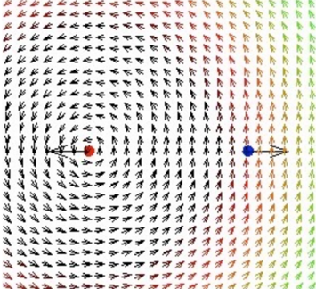
5. Example
6. Inside the coil, what is direction of B-field?
7. 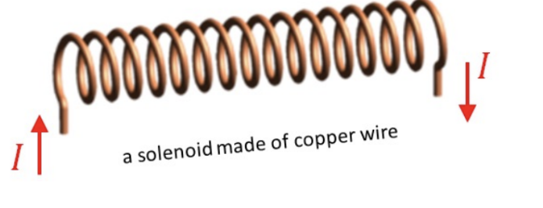
8. Field is toward the right